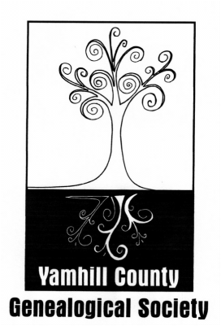

Educational Programs 2019-2020

On the 1st Saturday of each Month at the McMinnville Public Library, Carnegie Room

225 NE Adams Street, McMinnville, Oregon

Social Time: 9:30 – 10:00 am / Educational Program: 10:00 – 11:00 am

September 7: Video and Discussion about Crafting Your Genealogy Research Plan,
Building a Surname Table, and Genealogy in the Year 2364.
Discussion Leader: Debra Millegan

October 5: Video and Discussion about how to use Google for Genealogy.
Discussion Leader: Debra Millegan

November 2: Beyond Names and Dates: Filling in the Stories of Our Female Ancestors
Guest Speaker: Pam Vestal

December 7: Video and Discussion about DNA Tests – which one is the best one to use? Basics of how to use it once you get the results back.
Discussion Leader: Debra Millegan

January 2: Video and Discussion for the beginning (and intermediate) genealogist
Discussion Leader: Debra Millegan

February 1: Cemetery Restoration
Member Speaker: Kim Courtin

March 7: Tips when traveling to do Genealogy Research
Member Speaker: Vicki Gross

April: 4 Video and Discussion about Census Records Do’s and Don’ts
Discussion Leader: Debra Millegan

May 2: Voting Records: Genealogy's Best Kept Secret
Guest Speaker: Pam Vestal

June 6: DNA and Genealogy
Member Speaker: Kim Courtin

